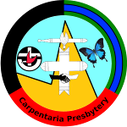

Carpentaria Presbytery

Model minute for Church Councils with NO children’s activities:
To comply with the Act, each church council is required to annually formally adopt (or reaffirm) that no children’s activities are to be held within the year and a record of this written statement is to be minuted in the Church Council Minutes. Here is some suggested wording:

Date:.........
Congregation.......................................................................................
”The church council resolves that they will not conduct ministry with children until further notice. Accordingly no church council member will be under statutory obligation to hold a blue card for the purpose of their office.”

This meets the requirements of the Act in outlining the degree of commitment the Church has to the Safe Ministry With Children Program.

Signature.........................................................
Council Chairperson

Print Name:........................................................

